Learning diary

**Week 1**

On week one we only had meeting to discuss our project and we found ourselves a great plan. We want to make an automatic blinds closer/opener. We will need stepper motor, Arduino and casing for the device. Our plan should be easy making and we think that we will not have any major problems.

Also, at week one I was at all the lectures and learned all the skills to make this project work.

**Week 2**

Week two we could not get any real work done on our project, but I was on the lectures again and honed my skills at 2D and 3D fabrication. Others worked and prepared their selves on their own ways.

**Week 3**

Preparation for mid-term presentation and the presentation. Also, schedueling our next moves. Some 3D modeling

**Week 4**

Week four we started to really get our heads together and push the project as far as we can. And we did just that. We got together on discord one day and just started to work. That night we worked hard, fast and long. We got the 3D model finished. In tinkercad we started our wiring and then started to code the Arduino. Hard part was to get breadboard to work correctly. Breadboards were new to few of us.

**Week 5**

Learning more about coding and trying to get our code to work. Problems occurred were with the coding language, these problems were fixed with a quick google search. Started to plan the final presentation.

**Week 6**

Working on the final presentation and trying to get the sensors working on Arduino. Problem was to get the stepper motor to not spin at 9000 rpm that’s just too much for our project.

Overall, not many problems just a small things with the code and those problems were easy to fix with tweaks on the code. Biggest problem of this project was to find time together to do this.

**Summary of my work**

I helped the team as much as I could. I am this teams weakest link cause I do not have the experience of my teammates. I did a lot of research for this project like how we could get these things working together. I learned how to use autodeks fusion 360 and tinkercad, also I got a punch of coding experience by writing code and try to help to get the motor to work. I was completely new to 3D and 2D modeling and after this course I would say I could myself 3D and 2D print something.

**Pictures of the project**

First sketch of the product (Week 1)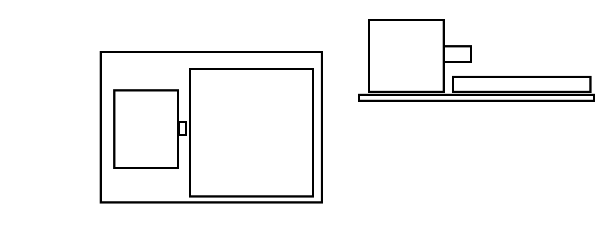

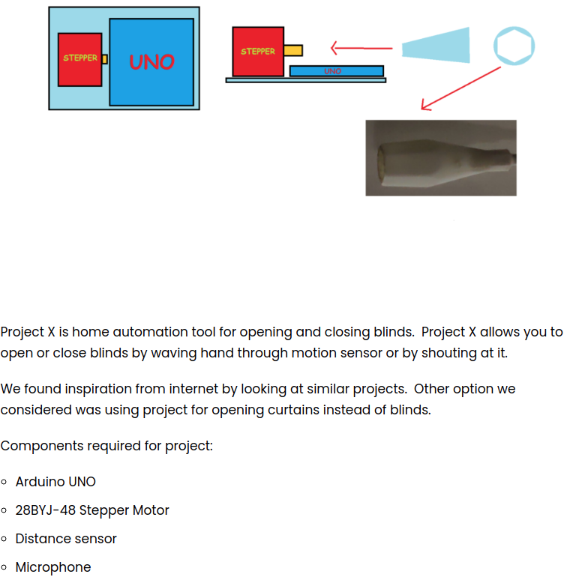

Very early motor trials (week 3 and 4)

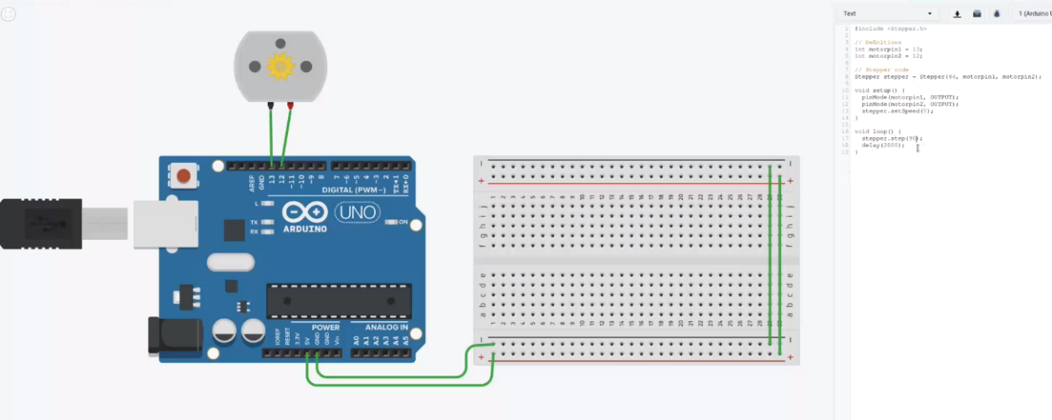

Finished 3D model of the connector to the blinds control (week 3 and 4)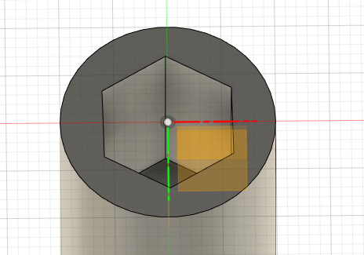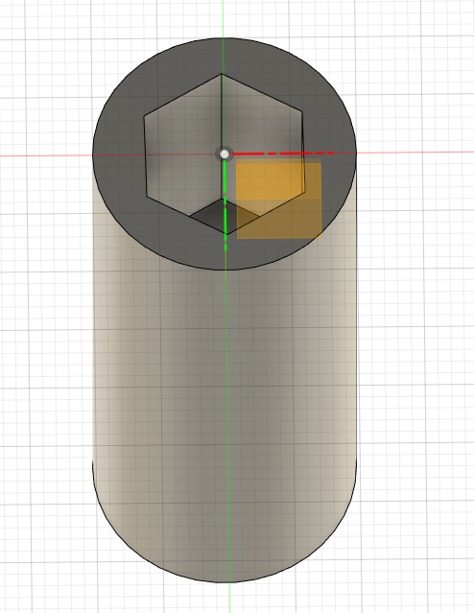

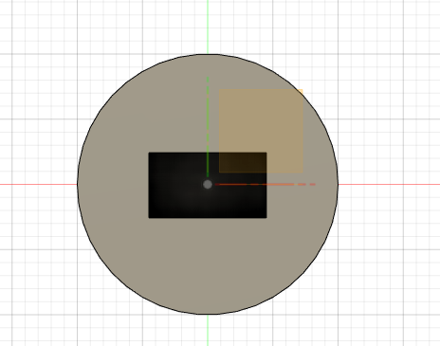

3D models of the casing (week 3 and 4)

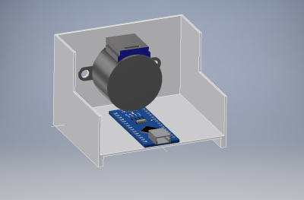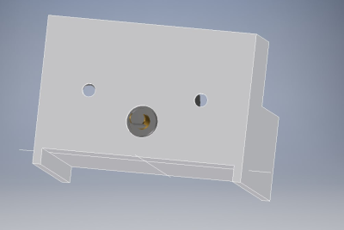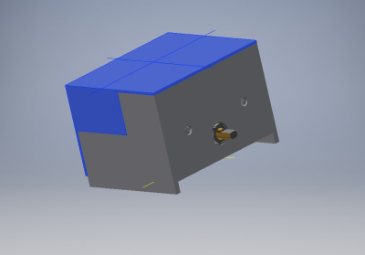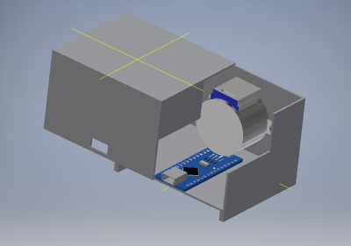

Closer to the finished thing (Week 5 and 6) (motor did not work so went back to the other motor)

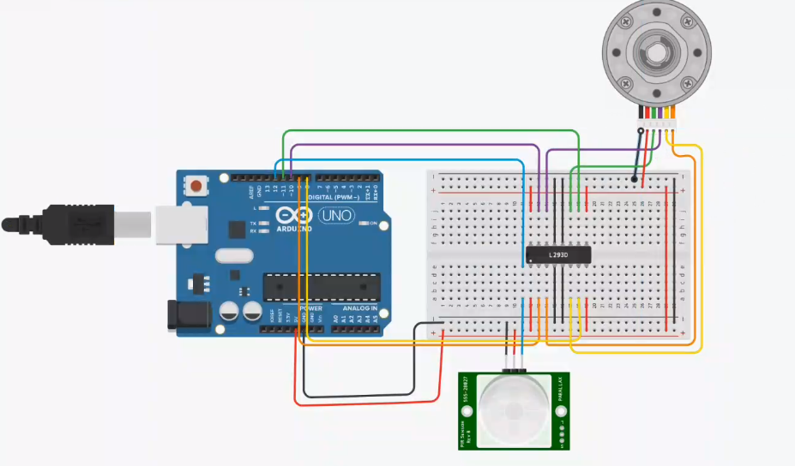

**What’s next**

If we could have gotten the components and more time the prototype would be finished and working. The problems with prototype would have been the resistance between motor and the blinds. Some tweaks to code and then it would have probably work.

Jussi Vesaranta